HTML Table

Table of content

* What is HTML table?
* What is Border property in HTML table?
* Explain Border collapsed property in HTML table.
* How to create table row and column in HTML document?
* Explain the concept of Padding in HTML table.
* Explain the concept of Border spacing in HTML.
* How to add table header, table body and table footer?
* What is table background?
* Explain the concept of Colspan and Rowspan in HTML table.
* Height and width attribute in HTML table.

What is HTML table?

HTML language allows the user to create and maintain their data in tabular format. HTML table is use for create table so that user can maintain their data. The HTML <table> tag is use for creating table. <table> tag consist of table row, table data, table heading, table body and table footer etc.

<table> -

The <table> tag is use for creating table. This tag can be written as a <table> and </table>

<tr> **-**

The <tr> tag represents table row in table. This tag is written under the main table tag and start with <tr> tag and it is end with </tr> tag.

<td> -

The <td> tag is use for creating table data or represents the information in table column. This tag is written under tr tag which starts with <td> and ends with </td>. The <td> tag contain anything text, image, list element etc.

Example- (Simple Example of HTML table by using <table> tag, <tr> tag, and <td>tag).

<!DOCTYPE html>

<html>

  <head>

    <title>Table Tutorial</title>

  </head>

  <body>

    <table style="width: 50%">

      <tr>

        <td>Name</td>

        <td>Roll no</td>

        <td>Section</td>

      </tr>

      <tr>

        <td>Ram</td>

        <td>1</td>

        <td>A</td>

      </tr>

      <tr>

        <td>Komal</td>

        <td>2</td>

        <td>B</td>

      </tr>

    </table>

  </body>

</html>

Output- This output is only showing table data in the row and column.



What is Border property in HTML table?

For applying border to the HTML table CSS border property is use.

Example-

<!DOCTYPE html>

<html>

  <head>

    <title>Tables Border</title>

  </head>

  <style>

    table,

    tr,

    td {

      border: 1px solid black;

    }

  </style>

  <body>

    <h4>Here CSS border property is use to apply the border to the table.</h4>

    <table style="width: 50%">

      <tr>

        <td>Student Name</td>

        <td>School</td>

      </tr>

      <tr>

        <td>Ramesh</td>

        <td>New English School</td>

      </tr>

      <tr>

        <td>Rahul</td>

        <td>New English School</td>

      </tr>

    </table>

  </body>

</html>

Output-

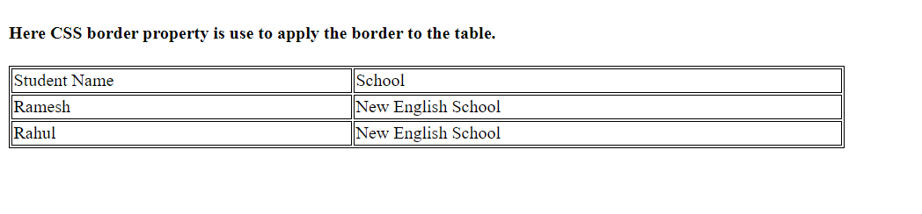

Explain Border collapsed property in HTML table.

This property allows the table border to collapsed into one single border.

Example-

<!DOCTYPE html>

<html>

  <head>

    <title>Border collapse</title>

  </head>

  <style>

    table,tr,td {

      border: 1px solid black;

      border-collapse: collapse;

    }

    tr,td {

      padding: 10px;

    }

  </style>

  <body>

    <h4>This is an example of border collapse.</h4>

    <table style="width: 50%">

      <tr>

        <td></td>

        <td></td>

        <td></td>

        <td></td>

      </tr>

      <tr>

        <td></td>

        <td></td>

        <td></td>

        <td></td>

      </tr>

      <tr>

        <td></td>

        <td></td>

        <td></td>

        <td></td>

      </tr>

    </table>

  </body>

</html>

Output-

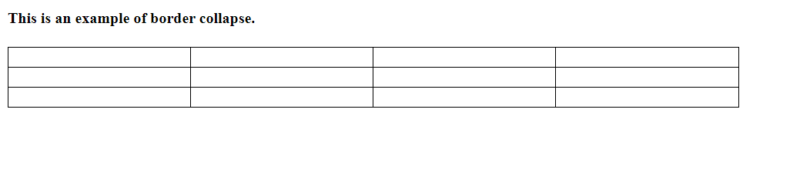

How to create table row and column in HTML document?

HTML table consist of table row and table data. For creating table row and table data <tr> tag for row and <td> tag for table data is used.

The <tr> tag and <td> tag is use under the <table> tag. For creating HTML table first <table> tag need to define. Inside the <table tag>, <tr> tag and <td> tag is use.

Example-

<!DOCTYPE html>

<html>

  <head>

    <title> HTML Table</title>

  </head>

  <body>

      <p>Example of Table</p>

    <table width="25%" border="1">

      <tr>

        <td>Name</td>

        <td>Branch</td>

      </tr>

      <tr>

        <td>Rajiv</td>

        <td>Information Technology</td>

      </tr>

      <tr>

        <td>Gita</td>

        <td>Computer science</td>

      </tr>

    </table>

  </body>

</html>

Output-

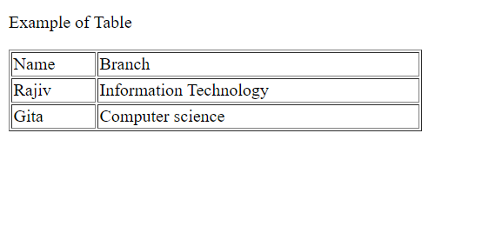

Explain the concept of padding in HTML table.

Padding is a concept of adding a space between text area and the border.

Example-

<!DOCTYPE html>

<html>

  <head>

    <title>Table Tutorial</title>

  </head>

  <style>

    table,tr,td {

      border: 1px solid black;

    }

    tr,td {

      padding: 10px;

    }

  </style>

  <body>

    <h4>This is an example of blank table with Padding and Border.</h4>

    <table style="width: 50%">

      <tr>

        <td></td>

        <td></td>

        <td></td>

        <td></td>

      </tr>

      <tr>

        <td></td>

        <td></td>

        <td></td>

        <td></td>

      </tr>

      <tr>

        <td></td>

        <td></td>

        <td></td>

        <td></td>

      </tr>

    </table>

  </body>

</html>

Output-

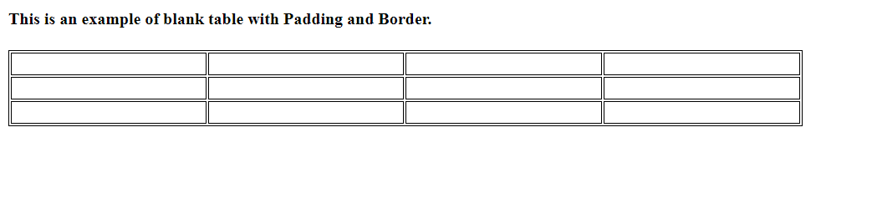

Example-

<!DOCTYPE html>

<html>

  <head>

    <title>padding</title>

  </head>

  <style>

    table,tr,td {

      border: 1px solid black;

    }

    tr,td {

      padding: 30px;

    }

  </style>

  <body>

    <h4>This is an example of blank table with Padding with 30px.</h4>

    <table style="width: 50%">

      <tr>

        <td>Name</td>

        <td>Address</td>

        <td>Email-id</td>

        <td>Mob no</td>

      </tr>

      <tr>

        <td>Ankita</td>

        <td>Akola</td>

        <td>xyz@gmail.com</td>

        <td>123456</td>

      </tr>

      <tr>

        <td>Raj</td>

        <td>Nagpur</td>

        <td>abc@gmail.com</td>

        <td>45678789</td>

      </tr>

    </table>

  </body>

</html>

Output-

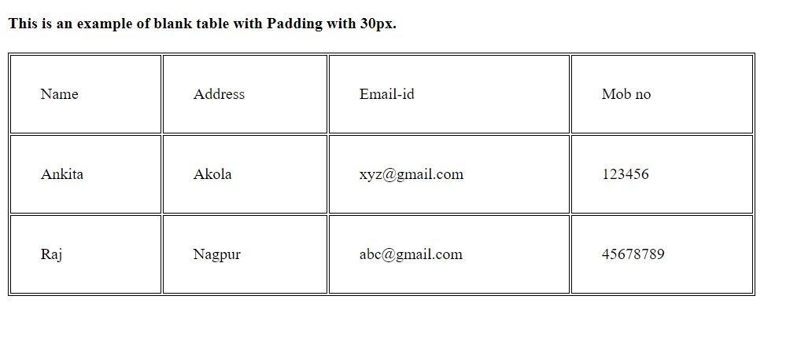

Explain the concept of Border spacing in HTML.

Border spacing concept is use to provide spacing between border and table cells.

Example-

<!DOCTYPE html>

<html lang="en">

<head>

    <meta charset="UTF-8">

    <meta name="viewport" content="width=device-width, initial-scale=1.0">

    <title>Document</title>

</head>

<style>

    table, tr, td{

        border: 1px solid black;

        border-spacing: 13px;

    }

</style>

<body>

    <p>This is an example of border spacing with 13px.</p>

    <table  >

            <tr>

            <td>Department</td>

            <td>No of employee</td>

            <td>Weekoff</td>

            </tr>

            <tr>

            <td>Tech support</td>

            <td>33</td>

            <td>Sunday</td>

            </tr>

            <tr>

            <td>BPO</td>

            <td>50</td>

            <td>Friday</td>

            </tr>

            <tr>

            <td>Software Engineer</td>

            <td>40</td>

            <td>Saturday</td>

            </tr>

             <td>Software Developer</td>

            <td>40</td>

            <td>Sunday</td>

            </tr>

             <td>Web Developer</td>

            <td>40</td>

            <td>Saturday</td>

            </tr>

    </table>

</body>

</html>

Output-

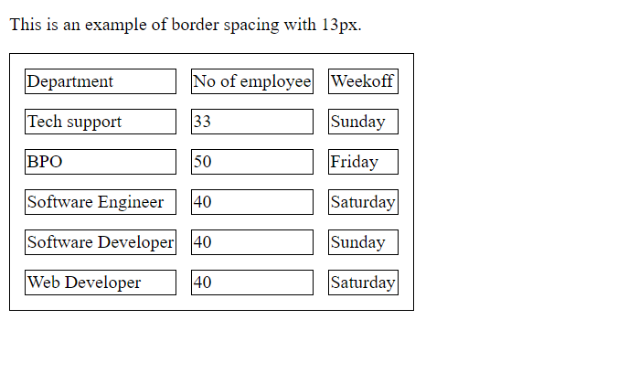

What is table heading, which tag is use for represent table heading?

HTML heading is user for providing table heading to the table. For heading <th> tag is use. This tag is use under <tr> tag.

<th> - Table heading is represented by <th> tag.

Example-

<!DOCTYPE html>

<html>

  <head>

    <title>Table header</title>

  </head>

  <style>

    table,th,td {

      border: 1px solid black;

    }

  </style>

  <body>

      <p>This is an example of Table Heading.</p>

    <table width="50%">

      <tr>

        <th>Weekday</th>

        <th>Subject</th>

      </tr>

      <tr>

        <td>Monday</td>

        <td>Maths</td>

      </tr>

      <tr>

        <td>Tuesday</td>

        <td>English</td>

      </tr>

      <tr>

        <td>Wednesday</td>

        <td>Science</td>

      </tr>

    </table>

  </body>

</html>

Output-

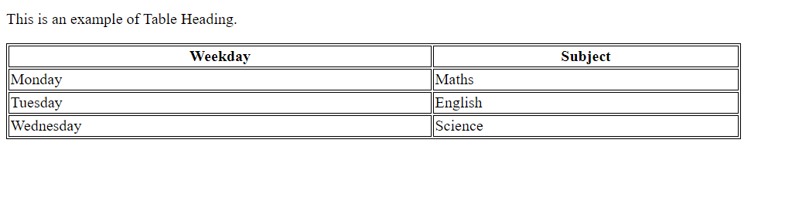

How to add table header, table body and table footer?

For adding table header, table footer and table body different tags should be added under table tag.

Tags are given below-

<thead> **-** use for creating table header.

<tbody> **-** This tag is use for representing table body.

<tfoot> - This tag is use for representing table footer.

<thead>-This is use for table heading.

Syntax-

<table>

<thead>

<td> data</td>

</thead>

</table>

<tbody>-This is use for table body.

Syntax-

<table>

<tbody>

<td> data</td>

</tbody>

</table>

<tfoot>-This is use for table footer.

Syntax-

<table>

<tfoot>

<td> data</td>

</tfoot>

</table>

**Example-**

<!DOCTYPE html>

<html lang="en">

  <head>

    <meta charset="UTF-8" />

    <meta name="viewport" content="width=device-width, initial-scale=1.0" />

    <title>Document</title>

  </head>

  <style>

    table,thead,tbody,tfoot,tr,td {

      border: 1px solid black;

    }

  </style>

  <body>

    <table width="50%">

      <thead>

        <tr>

          <td colspan="3">This is Table Header represents Student data</td>

        </tr>

      </thead>

      <tbody>

        <tr>

          <td>Name</td>

          <td>mob no</td>

          <td>Email-id</td>

        </tr>

      </tbody>

      <tfoot>

        <tr>

          <td colspan="3">Thank you</td>

        </tr>

      </tfoot>

    </table>

  </body>

</html>

**Output-**

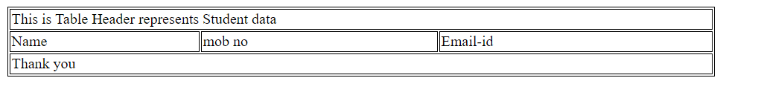

What is table background?

HTML table is use to provide background color as well as background image.

Example-

<!DOCTYPE html>

<html>

  <head>

    <title>Table Background</title>

  </head>

  <style>

    table,td,th {

      background-color: #fffaec;

      border: 1px solid black;

    }

  </style>

  <body>

    <p>

      You can change Background color of the table by using background-color

      property.

    </p>

    <table width="50%">

      <tr>

        <th>Name</th>

        <th>Salary</th>

      </tr>

      <tr>

        <td>Rakesh</td>

        <td>20,000</td>

      </tr>

      <tr>

        <td>Rahul</td>

        <td>21,000</td>

      </tr>

      <tr>

        <td>Rama</td>

        <td>24,000</td>

      </tr>

    </table>

  </body>

</html>

Output-

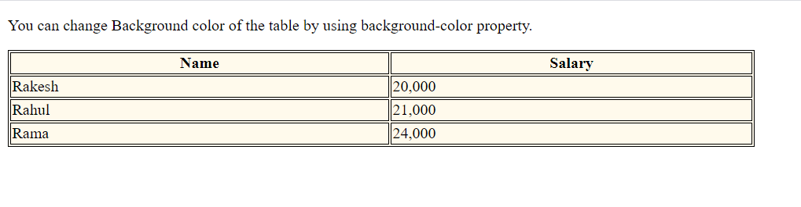

Explain the concept of Colspan and Rowspan in HTML table.

Colspan-

Colspan is use for merging the two or more column into a single column.

Example-

  <!DOCTYPE html>

<html lang="en">

  <head>

    <meta charset="UTF-8" />

    <meta name="viewport" content="width=device-width, initial-scale=1.0" />

    <title>Document</title>

  </head>

  <body>

    <style>

      table,

      th,

      td {

        border: 1px solid black;

        border-collapse: collapse;

      }

    </style>

    <p>Example of Colspan.</p>

    <table width="50%">

      <tr>

        <td colspan="4">Student Profile details</td>

      </tr>

      <tr>

        <td>Name</td>

        <td>Address</td>

        <td colspan="2">Contact Details</td>

      </tr>

      <tr>

        <td>Ram</td>

        <td>India</td>

        <td>12345</td>

        <td>12345</td>

      </tr>

      <tr>

        <td>Nita</td>

        <td>India</td>

        <td>987654</td>

        <td>76543</td>

      </tr>

      <tr>

        <td>Raghu</td>

        <td>India</td>

        <td>76543</td>

        <td>456789</td>

      </tr>

    </table>

  </body>

</html>

Output-

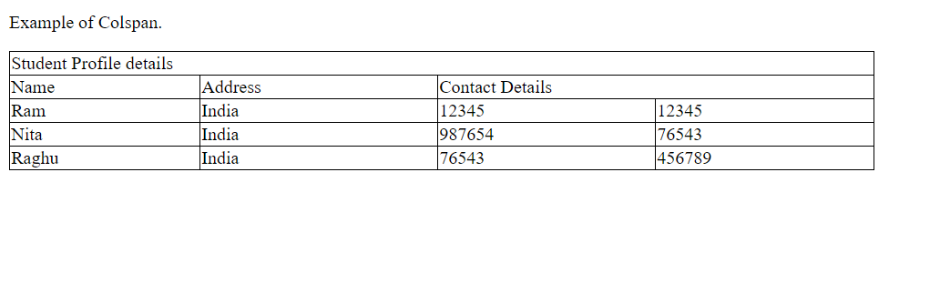

**Rowspan-**

Rowspan is use for merging the two or more row into a single row.

Example-

<!DOCTYPE html>

<html lang="en">

  <head>

    <meta charset="UTF-8" />

    <meta name="viewport" content="width=device-width, initial-scale=1.0" />

    <title>row span</title>

  </head>

  <body>

    <style>

      table,

      tr,

      td {

        border: 1px solid black;

      }

    </style>

    <p>Example of roespan.</p>

    <table width="50%">

      <tr>

        <td>Name of the Student</td>

        <td>Raju</td>

        <td>Rajat</td>

        <td>Chetan</td>

      </tr>

      <tr>

        <td rowspan="2">Telephone</td>

        <td>987123456</td>

        <td>5678123456</td>

        <td>1234560987</td>

      </tr>

      <tr>

        <td>123567890</td>

        <td>3456123456</td>

        <td>789045678</td>

      </tr>

      <tr>

        <td>Email-id</td>

        <td>xyz@gmail.com</td>

        <td>abc@gmail.com</td>

        <td>pqr@gmail.com</td>

      </tr>

    </table>

  </body>

</html>

Output-

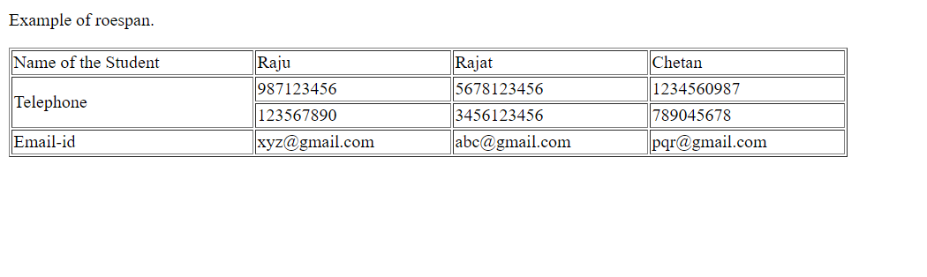

**Height and width attribute in HTML table.**

Height and width attribute use for providing height and width to the table. It is declared in the main table tag.

**Example-**

<!DOCTYPE html>

<html lang="en">

  <head>

    <meta charset="UTF-8" />

    <meta name="viewport" content="width=device-width, initial-scale=1.0" />

    <title>Document</title>

  </head>

  <style>

    table,

    tr,

    td {

      border: 1px solid black;

      border-collapse: collapse;

    }

  </style>

  <body>

    <table height="50%" width="50%">

      <tr>

        <td>First Name</td>

        <td>Last Name</td>

      </tr>

      <tr>

        <td>Rahul</td>

        <td>Roy</td>

      </tr>

      <tr>

        <td>Rajat</td>

        <td>Sharma</td>

      </tr>

    </table>

  </body>

</html>

Output- In the below output occupy 50% Width And 50% height according to code.

